
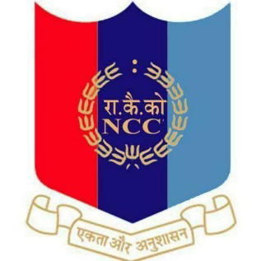



Report on Basic Life Support (BLS) Awareness Program

The Cardiopulmonary resuscitation (CPR) day was celebrated from 17th to 21 July. It is an emergency procedure that can help save a person's life if their breathing or heart stops. It was conducted by the INDIAN ACADEMY OF PEDIATRICS. The event was volunteered by 47 NCC cadets in the college’s Conference hall. 21 SD Cadets and 26 SW cadets participated in the program under the guidance of rector (Dr). Fr.Joby Joseph and Lt. Garland S Swett(ANO). The program was performed on dummies and the program was performed in 2 steps 30/2 the next task was on choking fast aid. After the program ended there was a group photo session. Certificate of participation was given and refreshments were also provided.

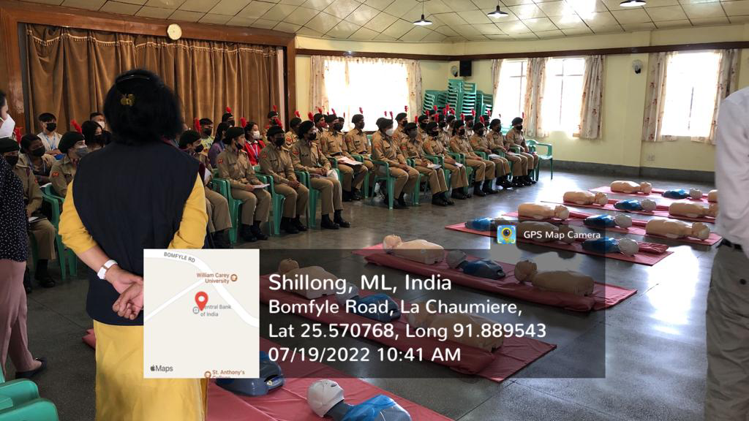
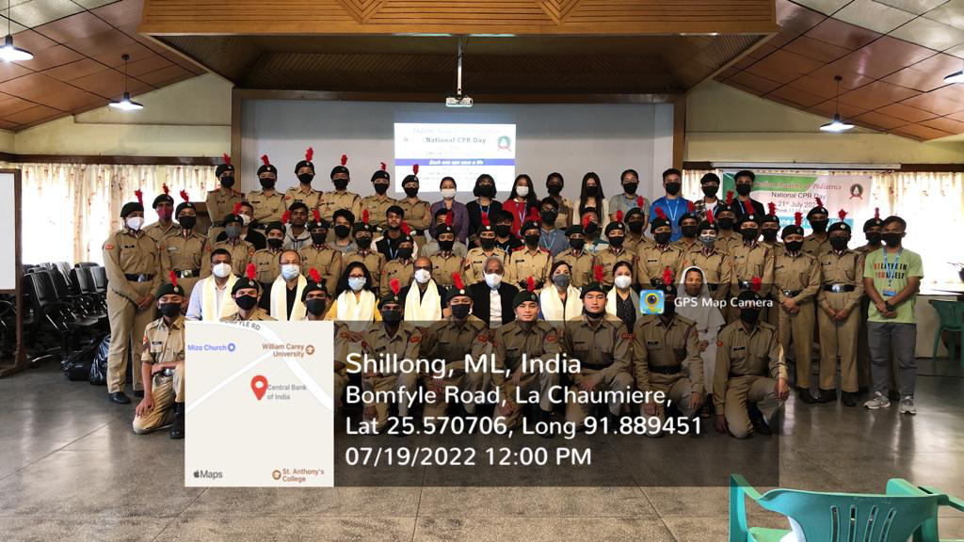
List of SD cadets who participated in CPR program
Sl.no | Regimental number | Rank | Name | Department | Shift
1 | ML20SDA103051 | SUO | Ronit chettri | Commerce | Day
2 | ML20SDA103071 | SGT | Lalremtluanga | Commerce | Morning
3 | ML20SDA103054 | CPL | Anurag thakur | Statistics | Day
4 | ML20SDA103089 | LCPL | Bipin kumar | BBA | Morning
5 | ML20SDA103090 | LCPL | Alok kumar | Computer Science | Day
6 | ML21SDA100018 | CDT | Raja Yadav | Education | Morning
7 | ML21SDA100013 | CDT | Aiborlang Kharjana | Political science | Day
8 | ML21SDA100011 | CDT | Yash Thapa | Commerce | Morning
9 | ML21SDA100001 | CDT | Raphael lalrinchhana | Statistics | Day
10 | ML21SDA100004 | CDT | Sunny Zou | Philosophy | Morning
11 | ML21SDA100033 | CDT | Biplob Deb | Physics | Day
12 | ML21SDA100024 | CDT | Phyrnailang Suting | Political science | Morning
13 | ML21SDA100029 | CDT | Libanson Mynsong | Khasi | Morning
14 | ML21SDA100032 | CDT | Pintu Khakhalary | Zoology | Day
15 | ML21SDA100008 | CDT | Kunal Dey | Commerce | Morning
16 | ML21SDA100017 | CDT | Millenial Wahlang | Education | Day
17 | ML21SDA100025 | CDT | Shashi Kumar Roy | Commerce | Day
18 | ML21SDA100023 | CDT | Chandrasekhar Roy | Statistics | Day
19 | ML21SDA100027 | CDT | Mainkher Kshiar | Commerce | Morning
20 | ML21SDA100026 | CDT | Maogsunep T | Education | Day
21 | ML21SDA100009 | CDT | Santokhi Sagar Diwan | Education | Day

List of SW cadets who participated in the CPR program
Sl.no | Regimental number | Rank | Name | Department | Shift
1 | ML20SWA102054 | SUO | Soni Chettri | Commerce | Day
2 | ML20SWA102045 | JUO | Niketa Biswa | Economics | Morning
3 | ML20SWA103035 | CQMS | Anjali Chettri | Commerce | Morning
4 | ML20SWA102039 | LCPL | Bliss Zou | Philosophy | Day
5 | ML20SWA102042 | LCPL | Diksha Pradhan | Commerce | Morning
6 | ML20SWA102047 | SGT | Nengneitheng Haokip | Botany | Day
7 | ML21SWA102052 | Cadet | Lourembam Preyanka | Commerce | Day
8 | ML21SWA102035 | Cadet | Abhilasa Kumari Gupta | Commerce | Day
9 | ML21SWA102049 | Cadet | Sungya Khullo | Political science | Morning
10 | ML21SWA102040 | Cadet | Cynthia K Sunn | English | Day
11 | ML21SWA102037 | Cadet | Akansha Chettri | Computer science | Day
12 | ML21SWA102068 | Cadet | Anamika Singh | English | Morning
13 | ML21SWA102058 | Cadet | Sany Mary Marngar | Philosophy | Morning
14 | ML21SWA102060 | Cadet | Shailindaphi Dkhar | Education | Day
15 | ML21SWA102064 | Cadet | Unicy Dkhar | Political | Day
16 | ML21SWA102054 | Cadet | Fatima Warjri | Khasi | Day
17 | ML21SWA102050 | Cadet | Jessica Konsam | Chemistry | Day
18 | ML21SWA102056 | Cadet | Pratiksha Sil | English | Day
19 | ML21SWA102073 | Cadet | Liza Das | Education | Morning
10 | ML21SWA102057 | Cadet | Sangita Paul | Commerce | Morning
21 | ML21SWA102061 | Cadet | Sonnal Joshi | English | Day
22 | ML21SWA102051 | Cadet | Kritika Verma | Philosophy | Day
23 | ML21SWA102066 | Cadet | Wandakamonlang Lyngdoh | Education | Day
24 | ML21SWA102065 | Cadet | Vidisha Kharkongor | History | Day
25 | ML21SWA102059 | Cadet | Sarita Sangma | English | Morning
26 | ML21SWA102071 | Cadet | Deepsikha Das | Economics | Morning

