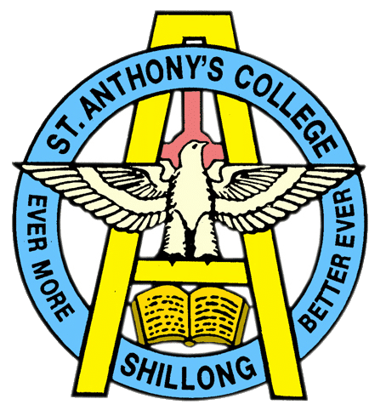
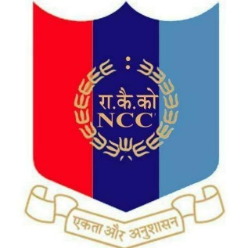
NATIONAL CADET CORPS
ST. ANTHONY’S COLLEGE
A Don Bosco Institution
Bomfyle Road, SHILLONG 793001

Indian Military Academy Attachment Camp

Indian Military Academy Attachment(IMA) Camp 2022 organized by 29 Uttarkhand Battalion in coordination with Indian Military Academy (IMA) fuel the fire within all NCC cadets who aspire to the Indian Army. The objective of the camp was to motivate NCC cadets and provide them with a holistic orientation to life at IMA with the character-building enshrined in the IMA honor code, warrior code, and motto. Cadets take part in a variety of sports, physical training, drills, weapons training, and leadership development activities.
Sergeant Kalp Jalan of 2 Meghalaya Battalion participated in the prestigious camp of Indian Military Academy (IMA) and total of 250 cadets were divided Into 4 companies – A, B, C, D, and the camp schedule was explained to each cadet by the respective Directorate senior, Cadets were given an Academy tour called “IMA Darshan”, the campus spreads over 1,400 acres (5.7 Km2), houses the Chetwode Hall, Khetarpal Auditorium, Somnath Stadium, Salaria Aquatic Centre, Hoshiar Singh Gymnasium, and other facilities that facilitate the training of cadets. Cadets in IMA are organized into a regiment with four battalions.

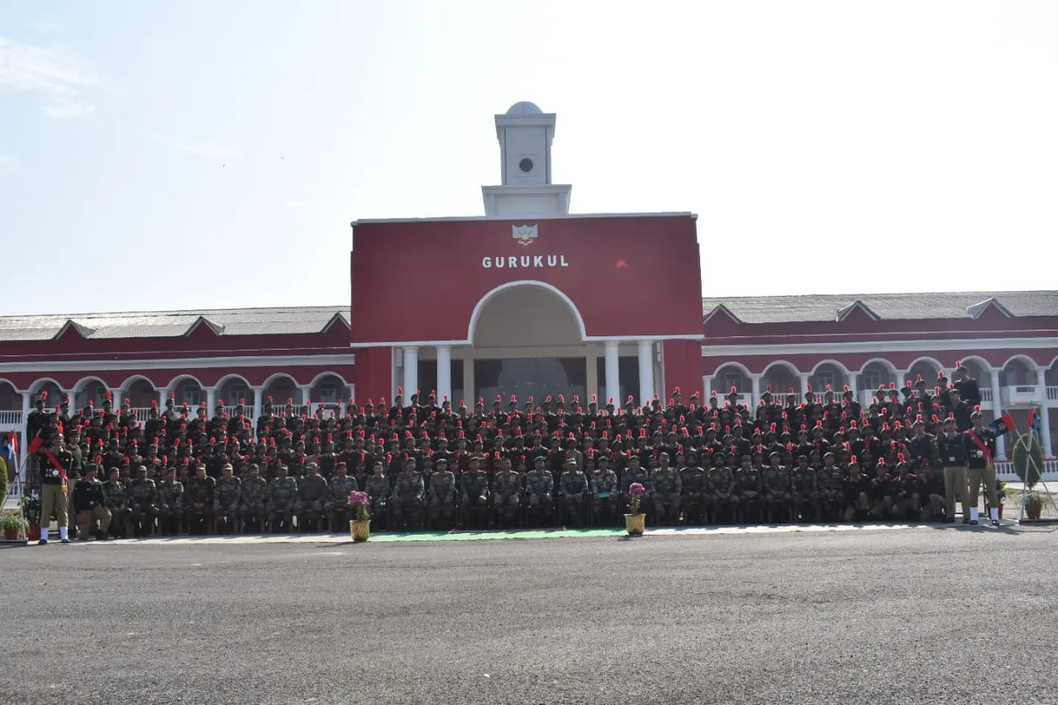
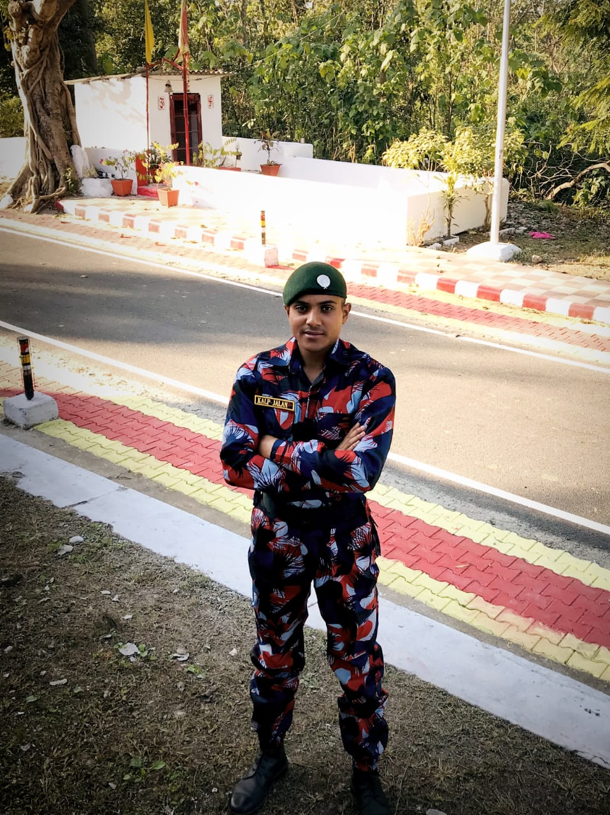

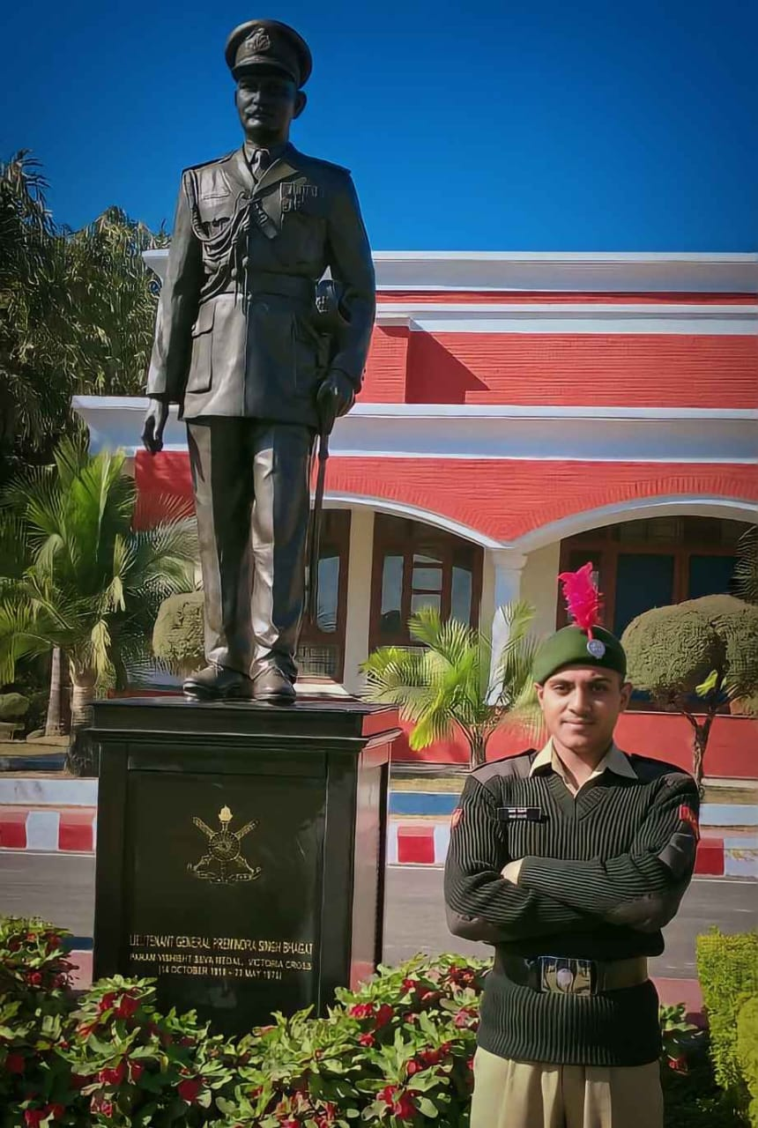
Sergeant. Kalp Jalan

