
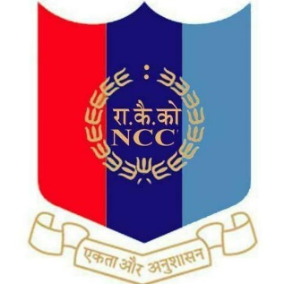
NATIONAL CADET CORPS
ST. ANTHONY’S COLLEGE
A Don Bosco Institution
Bomfyle Road, SHILLONG 793001

Report On Visit of Major Pankaj Bhattacharjee

On the 23rd of March,2022 , Major Pankaj Bhattacharjee visited St. Anthony’s College, Shillong to interact with the NCC cadets of the college.
Major Pankaj Bhattacharjee of the 17 Mahar Regiment currently posted at the one of the toughest peaks of Siachen Glacier, was a sepoy when he joined the army. It was the zeal and support from his family that led to him becoming a Lieutenant after 3 years at Army Cadet College(ACC) and a year at the Indian Military Academy(IMA) where he was the Battalion Under Officer. After the completion of his training at the IMA, was awarded with the President's Gold Medal in 2012 placing him amongst one of the meritus cadets of the academy.
He motivated the cadets on the perks of having a career in Indian defense, gave a detailed overview of the SSB process and its standards with reference to his experiences, and also narrated various stories from his early days in the army to his NSG Commando days.
In short, the cadets enjoyed every minute of the conversation and were filled with high levels of motivation and zeal inside their hearts to never give up and accomplish their dreams.
A total of 115 cadets attended the programme.

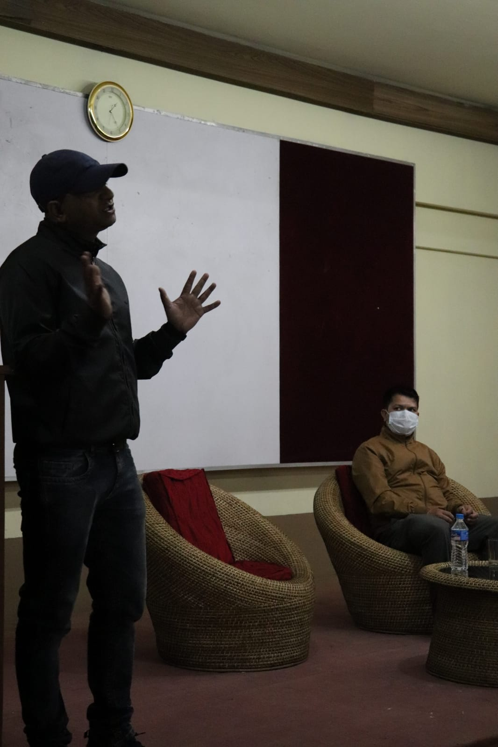
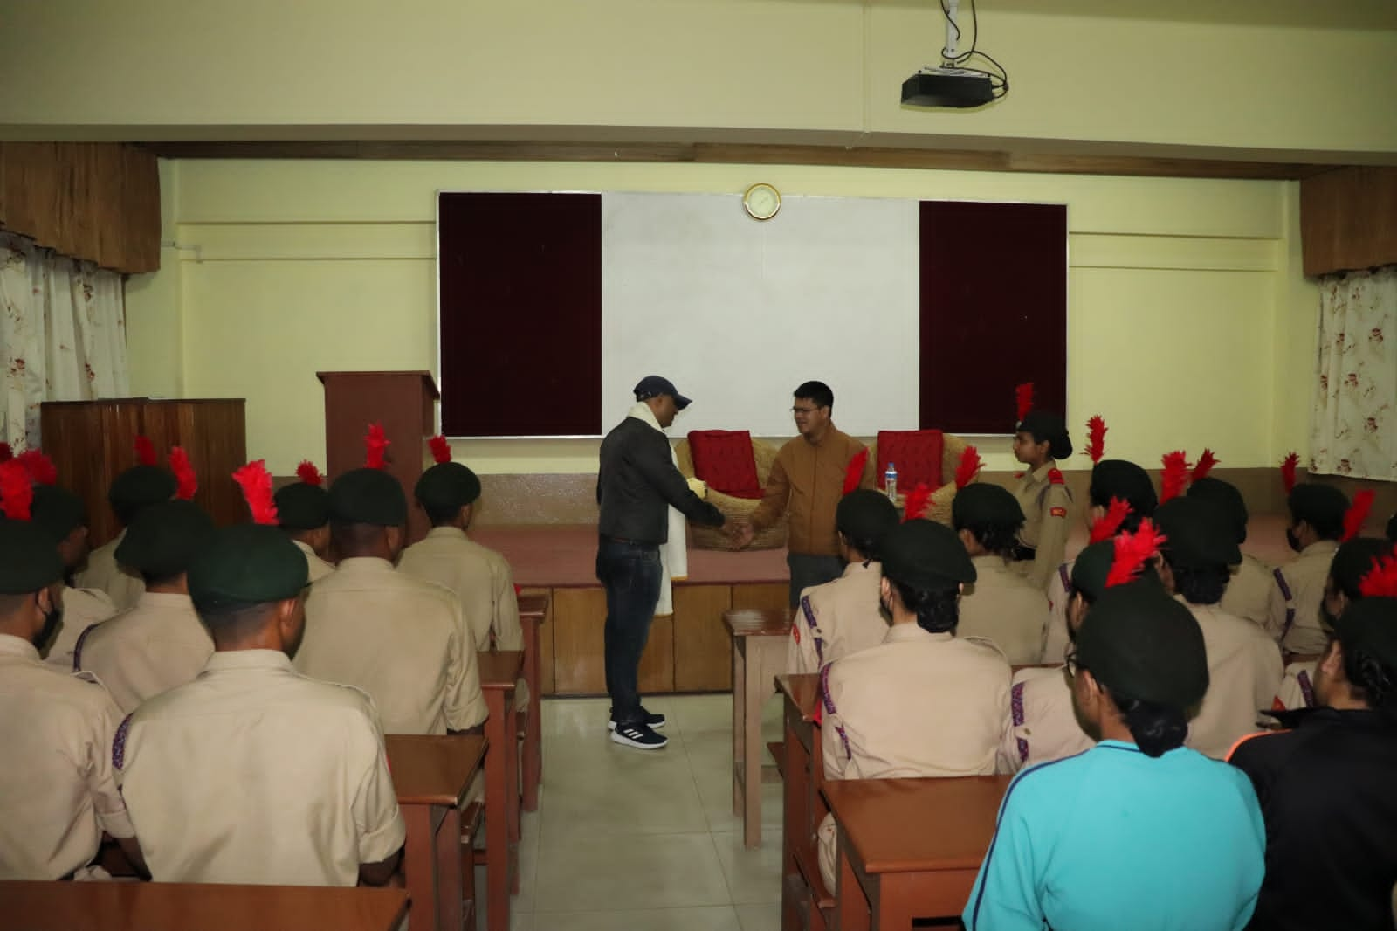
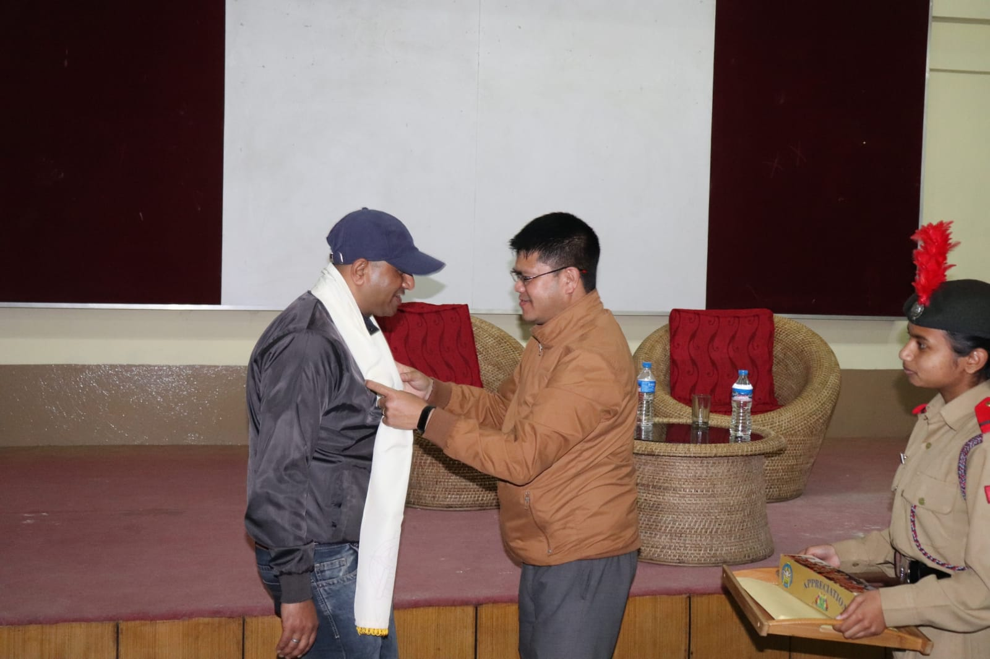
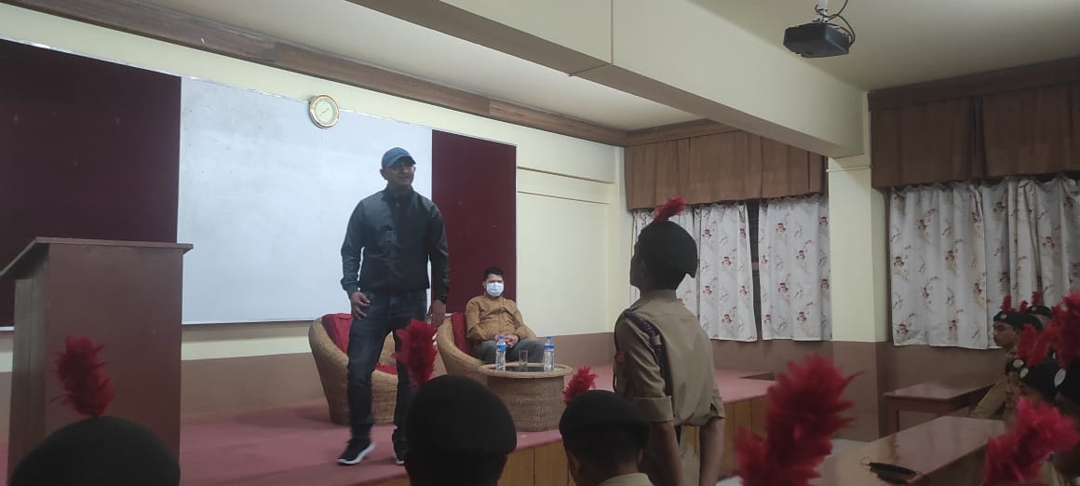
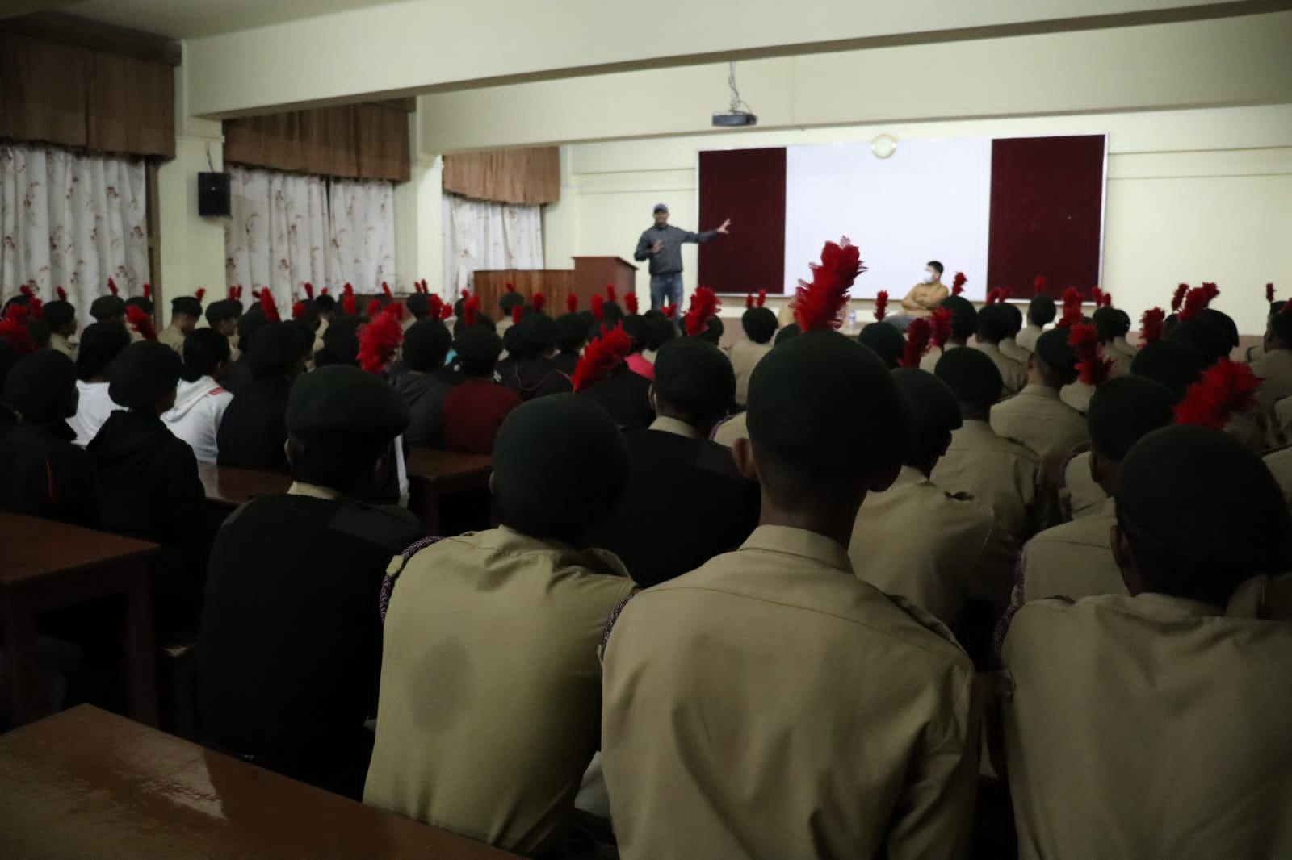

List of Cadets present for the programme:
SL. No. | Regimental Number | Rank | Name
1. | ML/19/SW/A/102035 | Cadet | Anita Lyngdoh Mairang
2. | ML/19/SW/A/102036 | Cadet | Badeishisha Youthborne
3. | ML/19/SW/A/102037 | Cadet | Baiahunlang Rynjah
4. | ML/19/SW/A/102042 | Cadet | Iakibansumar Khongmawpat
5. | ML/19/SW/A/102044 | CPL | Jyotika Malakar
6. | ML/19/SW/A/102049 | LCPL | Priyanka Phukan
7. | ML/19/SW/A/102050 | LCPL | Pronita Sinha
8. | ML/19/SW/A/102051 | JUO | Rinkey Kumari
9. | ML/19/SW/A/102052 | LCPL | Ritika Biswa
10. | ML/19/SW/A/102053 | SUO | Sajan Begum
11. | ML/19/SW/A/102056 | Cadet | Suklineshisha Kharkongor
12. | ML/19/SW/A/100054 | Cadet | Ladymon Thangkhiew
13. | ML/19/SW/A/100076 | Cadet | Sonam
14. | ML/19/SW/A/103078 | Cadet | Badakordor
15. | ML/20/SW/A/102035 | Cadet | Anjali Chettri
16. | ML/20/SW/A/102036 | Cadet | Archana Boruah
17. | ML/20/SW/A/102039 | Cadet | Bliss Zou
18. | ML/20/SW/A/102040 | Cadet | Cynthia. K. Sunn
19. | ML/20/SW/A/102041 | Cadet | Diksha Pradhan
20. | ML/20/SW/A/102045 | Cadet | Niketa Biswa
21. | ML/20/SW/A/102047 | Cadet | Nengneitheng Haokip
22. | ML/20/SW/A/102049 | Cadet | Sungnya Khullo
23. | ML/20/SW/A/102053 | Cadet | Ailin Gogoi
24. | ML/20/SW/A/102054 | Cadet | Soni Chettri
25. | ML/20/SW/A/102055 | Cadet | Dulanpaki Phawa
26. | ML/20/SW/A/102056 | Cadet | Uma Sonar
27. | ML/20/SW/A/102056 | Cadet | Karung Kezeah kom
28. | ML/21/SW/A/102035 | Cadet | Abhilasa Kumari Gupta
29. | ML/21/SW/A/102036 | Cadet | Aditi Subba
30. | ML/21/SW/A/102037 | Cadet | Akansha Chettri
31. | ML/21/SW/A/102068 | Cadet | Anamika singh
32. | ML/21/SW/A/102041 | Cadet | Balmera B Marak
33. | ML/21/SW/A/102042 | Cadet | Bansara Marbaniang
34. | ML/21/SW/A/102067 | Cadet | Cherrilyne M Sawkmie
35. | ML/21/SW/A/102071 | Cadet | Deepsikha Das
36. | ML/21/SW/A/102070 | Cadet | Dipali Paul
37. | ML/21/SW/A/102072 | Cadet | Eva Gracia Mary Kharumnuid
38. | ML/21/SW/A/102054 | Cadet | Fatima Baiahunlang Warjri
39. | ML/21/SW/A/102047 | Cadet | Fn Lalduhawmi
40. | ML/21/SW/A/102074 | Cadet | Isha rai
41. | ML/21/SW/A/102050 | Cadet | Jessica Konsam
42. | ML/21/SW/A/102051 | Cadet | Kritika verma
43. | ML/21/SW/A/102073 | Cadet | Liza Das
44. | ML/21/SW/A/102053 | Cadet | Melody Lalduhzuali
45. | ML/21/SW/A/102056 | Cadet | PRATIKSHA SIL
46. | ML/21/SW/A/102069 | Cadet | Priti Kumari Ray
47. | ML/21/SW/A/102057 | Cadet | Sangita Paul
48. | ML/21/SW/A/102058 | Cadet | Sany Mary Marngar
49. | ML/21/SW/A/102059 | Cadet | Sarita Sangma
50. | ML/21/SW/A/102060 | Cadet | Shailindaphi Dkhar
51. | ML/21/SW/A/102061 | Cadet | Sonnal Joshi
52. | ML/21/SW/A/102062 | Cadet | Stephani Amse
53. | ML/21/SW/A/102063 | Cadet | Sweety Singha
54. | ML/21/SW/A/102064 | Cadet | Unicy Dkhar
55. | ML/21/SW/A/102065 | Cadet | Vidisha kharkongor
56. | ML/21/SW/A/102066 | Cadet | Wandamonlang
57. | ML/19/SD/A/103022 | SUO | Bankerlang Nongkhlaw
58. | ML/19/SD/A/103043 | JUO | Rivaaz Subba
59. | ML/19/SD/A/103044 | JUO | Pankaj Kumar Sah
60. | ML/19/SD/A/103003 | JUO | Hiluwang Pamei
61. | ML/19/SD/A/103047 | JUO | Daniel Vanlalchhana
62. | ML/19/SD/A/103019 | CQM | Hriivei Dicson
63. | ML/19/SD/A/103021 | SGT | Lalnunsang
64. | ML/19/SD/A/103016 | SGT | Bikas Chettry
65. | ML/19/SD/A/103007 | CPL | Arbin Ekka
66. | ML/19/SD/A/103050 | CPL | Shimkordor Lyngdoh Nonglait
67. | ML/19/SD/A/103142 | LCPL | Orison Lyngdoh
68. | ML/19/SD/A/104517 | Cadet | Anarjeet Kumar Roy
69. | ML/19/SD/A/104502 | Cadet | Nikhil Ray
70. | ML/19/SD/A/100045 | Cadet | Rohit Thakur
71. | ML/19/SD/A/100096 | Cadet | Reyya Seshu
72. | ML/19/SD/A/100091 | Cadet | Roshan Sharma
73. | ML/20/SD/A/103084 | Cadet | Nongku Panggeng
74. | ML/20/SD/A/103059 | Cadet | Vivek Kumar
75. | ML/20/SD/A/103052 | Cadet | Priyangkush Das
76. | ML/20/SD/A/103061 | Cadet | Raj Vijay Joshi
77. | ML/20/SD/A/103062 | Cadet | Marvin Dalambha Sawkmie
78. | ML/20/SD/A/103077 | Cadet | Nishant Das
79. | ML/20/SD/A/103072 | Cadet | Kalp Jalan
80. | ML/20/SD/A/103067 | Cadet | Soriso Y Yimchunger
81. | ML/20/SD/A/103080 | Cadet | Talong Taring
82. | ML/20/SD/A/103081 | Cadet | Ujjal Malakar
83. | ML/20/SD/A/103085 | Cadet | Dameskhemshisha Kharpran
84. | ML/20/SD/A/103093 | Cadet | Tc Laltluangliana
85. | ML/20/SD/A/103071 | Cadet | Lalremtluanga
86. | ML/20/SD/A/103051 | Cadet | Ronit Chettri
87. | ML/20/SD/A/103090 | Cadet | Alok Kumar
88. | ML/20/SD/A/103091 | Cadet | Philimon Dhar
89. | ML/20/SD/A/103054 | Cadet | Anurag Thakur
90. | ML/20/SD/A/103088 | Cadet | Raja Paul
91. | ML/20/SD/A/103074 | Cadet | Ioannis Ting
92. | ML/21/SD/A/100031 | Cadet | Iateilang kharshing
93. | ML/21/SD/A/100027 | Cadet | Maiñkher Kshiar
94. | ML/21/SD/A/100026 | Cadet | Maongsunep T
95. | ML/21/SD/A/100011 | Cadet | Yash Thapa
96. | ML/21/SD/A/100010 | Cadet | Puttu Kumar Singh
97. | ML/21/SD/A/100032 | Cadet | Pintu khakhalary
98. | ML/21/SD/A/100021 | Cadet | Lalnunpuia
99. | ML/21/SD/A/100014 | Cadet | Bakhamkyrpang Syiemlieh
100. | ML/21/SD/A/100001 | Cadet | Raphael Lalrinchhana
101. | ML/21/SD/A/100013 | Cadet | Aiborlang kharjana
102. | ML/21/SD/A/100005 | Cadet | Meer Hussain Choudhury
103. | ML/21/SD/A/100013 | Cadet | Rohit Rai
104. | ML/21/SD/A/100028 | Cadet | Phrangsngi Ingtih
105. | ML/21/SD/A/100016 | Cadet | Nischal joshi
106. | ML/21/SD/A/100017 | Cadet | Millenial wahlang
107. | ML/21/SD/A/100025 | Cadet | Shashi Kumar
108. | ML/21/SD/A/100009 | Cadet | Santohki Sagar
109. | ML/21/SD/A/100020 | Cadet | Abhay Paul
110. | ML/21/SD/A/100007 | Cadet | Ngamba Singha
111. | ML/21/SD/A/100019 | Cadet | Md Sahabuddin
112. | ML/21/SD/A/100022 | Cadet | Presenbirth Momin
113. | ML/21/SD/A/100024 | Cadet | Phyrnailang Suting
114. | ML/21/SD/A/100018 | Cadet | Raja Yadav
115. | ML/21/SD/A/100033 | Cadet | Biplob Deb

