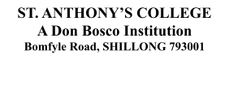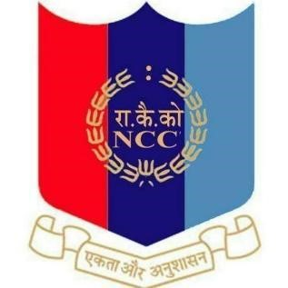
Paying Tribute to CDS Gen.Bipin Rawat, PVSM, UYSM, AVSM, YSM, SM, VSM, ADC
NCC UNIT
St Anthony’s college, Shillong
13th December 2021
Chief of Defence Staff Gen. Bipin Rawat, PVSM,UYSM,AVSM,YSM,SM,VSM,ADC , India’s first Chief of Defence Staff, who had a vast experience across a wide spectrum of conflict and terrain profiles, were among the 13 people who died in helicopter crash on Wednesday 8th December, 2021. Due to the foggy conditions the helicopter met an unfortunate crash in hilly areas near Coonoor in Tamil Nadu. Army personnel who lost their lives in the chopper crash were Gen.Bipin Rawat, Lieutenant Colonel Harjinder Singh, Brigadier L S Lidder, Wing Commander P S Chauhan, Squadron Leader
Kuldeep Singh, JWO Pradeep Arakkal, Junior Warrant Officer Rana Pratap Das, Havildar Satpal, Lance Naik Vivek Kumar and Lance Naik Sai Teja. Along with them, the general’s wife, Mrs Madhulika Rawat also died in the same crash incident. Paying homage to the chief of defence staff Gen Bipin Rawat and his wife Mrs Madhulika Rawat and all other 11 army personnel, 153 NCC Cadets of St. Anthony’s college along with our vice principal Fr Joby Joseph, Lt.Garland S Swett(ANO) NCC Unit, Senior Division St.Anthony’s College and Miss Dayomika Kharsyntiew ( CTO), NCC Unit Senior Wing lit candles on the 13th of December, 2021.

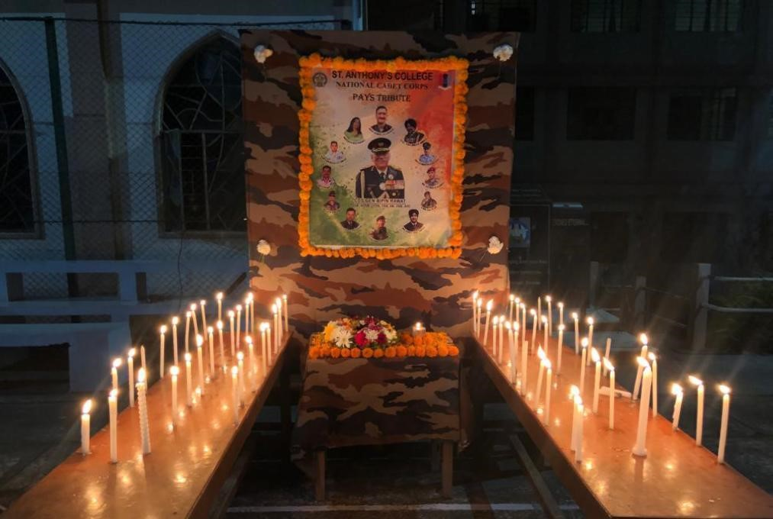
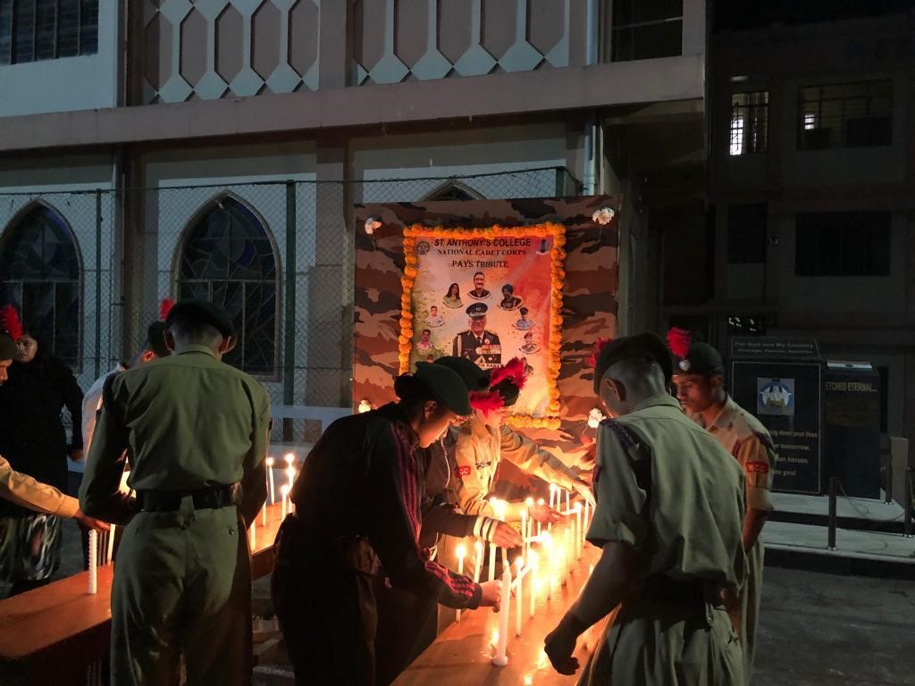
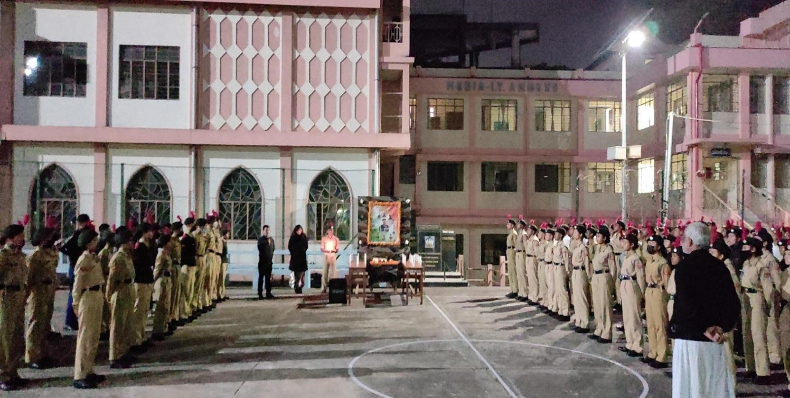

SL. No. | Reginmental No. | Rank | Name
1 | ML/19/SW/A/102035 | Cadet | Anita Lyngdoh Mairang
2 | ML/19/SW/A/102036 | Cadet | Badeishisha Youthborne
3 | ML/19/SW/A/102037 | Cadet | Baiahunlang Rynjah
4 | ML/19/SW/A/102038 | Cadet | Deimaia Nongrum
5 | ML/19/SW/A/102039 | LCPL | Diksha Singh Rathore
6 | ML/19/SW/A/102041 | SGT | Happiness Lyngdoh Nonglait
7 | ML/19/SW/A/102042 | Cadet | Iakibansumar Khongmawpat
8 | ML/19/SW/A/102044 | CPL | Jyotika Malakar
9 | ML/19/SW/A/102045 | Cadet | Koj Yassung
10 | ML/19/SW/A/102047 | Cadet | Nidawanshwa Pakma
11 | ML/19/SW/A/102048 | LCPL | Phiralin Suting
12 | ML/19/SW/A/102049 | LCPL | Priyanka Phukan
13 | ML/19/SW/A/102050 | LCPL | Pronita Sinha
14 | ML/19/SW/A/102051 | JUO | Rinkey Kumari
15 | ML/19/SW/A/102052 | LCPL | Ritika Biswa
16 | ML/19/SW/A/102053 | SUO | Sajan Begum
17 | ML/19/SW/A/102054 | Cadet | Srijana Chettri
18 | ML/19/SW/A/102055 | LCPL | Suchitra Tourangbam
19 | ML/19/SW/A/102056 | Cadet | Suklineshisha Kharkongor
20 | ML/20/SW/A/102035 | CADET | Anjali Chettri
21 | ML/20/SW/A/102036 | CADET | Archana Boruah
22 | ML/20/SW/A/102039 | CADET | Bliss Zou
23 | ML/20/SW/A/102040 | CADET | Cynthia. K. Sunn
24 | ML/20/SW/A/102041 | CADET | Diksha Pradhan
25 | ML/20/SW/A/102042 | CADET | Fabica Lyngdoh
26 | ML/20/SW/A/102045 | CADET | Niketa Biswa
27 | ML/20/SW/A/102047 | CADET | Nengneitheng Haokip
28 | ML/20/SW/A/102048 | CADET | Priyanka Singh
29 | ML/20/SW/A/102049 | CADET | Sungnya Khullo
30 | ML/20/SW/A/102050 | CADET | Supankari Chakma
31 | ML/20/SW/A/102053 | CADET | Ailin Gogoi
32 | ML/20/SW/A/102054 | CADET | Soni Chettri
33 | ML/20/SW/A/102055 | CADET | Dulanpaki Phawa
34 | ML/20/SW/A/102056 | CADET | Uma Sonar
35 | ML/20/SW/A/102056 | CADET | Karung Kezeah kom
36 | ML/21/SW/A/102035 | Cadet | Abhilasa Kumari Gupta
37 | ML/21/SW/A/102036 | Cadet | Aditi Subba
38 | ML/21/SW/A/102037 | Cadet | Akansha Chettri
39 | ML/21/SW/A/102068 | Cadet | Anamika singh
40 | ML/21/SW/A/102040 | Cadet | Baaijinghunlang Dkhar
41 | ML/21/SW/A/102041 | Cadet | Balmera B Marak
42 | ML/21/SW/A/102042 | Cadet | Bansara Marbaniang
43 | ML/21/SW/A/102067 | Cadet | Cherrilyne M Sawkmie
44 | ML/21/SW/A/102071 | Cadet | Deepsikha Das
45 | ML/21/SW/A/102070 | Cadet | Dipali Paul
46 | ML/21/SW/A/102045 | Cadet | ELARITA LAMARE
47 | ML/21/SW/A/102072 | Cadet | Eva Gracia Mary Kharumnuid
48 | ML/21/SW/A/102054 | Cadet | Fatima Baiahunlang Warjri

49 | ML/21/SW/A/102047 | Cadet | Fn Lalduhawmi
50 | ML/21/SW/A/102074 | Cadet | Isha rai
51 | ML/21/SW/A/102050 | Cadet | Jessica Konsam
52 | ML/21/SW/A/102051 | Cadet | Kritika verma
53 | ML/21/SW/A/102073 | Cadet | Liza Das
54 | ML/21/SW/A/102052 | Cadet | LOUREMBAM PREYANKA
55 | ML/21/SW/A/102053 | Cadet | Melody Lalduhzuali
56 | ML/21/SW/A/102055 | Cadet | Naphibanbet Thongni
57 | ML/21/SW/A/102056 | Cadet | PRATIKSHA SIL
58 | ML/21/SW/A/102069 | Cadet | Priti Kumari Ray
59 | ML/21/SW/A/102057 | Cadet | Sangita Paul
60 | ML/21/SW/A/102058 | Cadet | Sany Mary Marngar
61 | ML/21/SW/A/102059 | Cadet | Sarita Sangma
62 | ML/21/SW/A/102060 | Cadet | Shailindaphi Dkhar
63 | ML/21/SW/A/102061 | Cadet | Sonnal Joshi
64 | ML/21/SW/A/102062 | Cadet | Stephani Amse
65 | ML/21/SW/A/102063 | Cadet | Sweety Singha
66 | ML/21/SW/A/102064 | Cadet | Unicy Dkhar
67 | ML/21/SW/A/102065 | Cadet | Vidisha kharkongor
68 | ML/21/SW/A/102066 | Cadet | Wandakamonlang Lyngdoh
69 | ML19SDA103003 | JUO | Hiluwang Pamei
70 | ML19SDA103007 | CPL | Arbin Ekka
71 | ML19SDA103012 | CPL | Tynraibaskhem Nonglang
72 | ML19SDA103013 | JUO | Hmingthanzuala
73 | ML19SDA103016 | SGT | Bikas Chettry
74 | ML19SDA103018 | LCPL | Mivann Lamin Gayang
75 | ML19SDA103019 | Q.M | Hriivei Dicson
76 | ML19SDA103020 | LCPL | Sameer Thapa
77 | ML19SDA103021 | SGT | Lalnungsang
78 | ML19SDA103022 | SUO | Bankerlang Nongkhlaw
79 | ML19SDA103024 | LCPL | Avinash Kumar Yadav
80 | ML19SDA103043 | JUO | Rivaaz Subba
81 | ML19SDA103044 | JUO | Pankaj Kumar Sah
82 | ML19SDA103047 | JUO | Daniel Vanlalchhana
83 | ML19SDA103050 | CPL | Shimkordor Lyngdoh Nonglait
84 | ML19SDA103053 | LCPL | Cleophas Syiemlieh
85 | ML19SDA103090 | CPL | Skhemborlang Ryngksai
86 | ML19SDA103091 | LCPL | H. Adakho
87 | ML19SDA103142 | LCPL | Orison Lyngdoh
88 | ML19SDA100561 | SGT | Manshan Skhem Giri
89 | ML19SDA104517 | CDT | Anarjeet Kumar Roy
90 | ML19SDA104502 | CDT | Nikhil Ray
91 | ML19SDA100087 | CDT | Rohit Thakur
92 | ML19SDA100096 | CDT | Reyya Seshu
93 | ML18SDA100349 | CDT | Santosh Kumar Rai
94 | ML19SDA100091 | CDT | Roshan Sharma
95 | ML19SDA100086 | CDT | Aman Singh
96 | ML19SDA100092 | CDT | Pranab J. Dahal
97 | ML20SDA102051 | CDT | RONIT CHETTRI

98 | ML20SDA103052 | CDT | PRIYANGKUSH DAS
99 | ML20SDA103054 | CDT | ANURAG THAKUR
100 | ML20SDA103057 | CDT | YESTER JANONG
101 | ML20SDA103059 | CDT | VIVEK KUMAR
102 | ML20SDA103060 | CDT | JACOB THANGSONTUNG ZOU
103 | ML20SDA103061 | CDT | RAJ VIJAY JOSHI
104 | ML20SDA103062 | CDT | MARVIN DALAMBHA SAWKMIE
105 | ML20SDA103063 | CDT | SEIVICTON HAOKIP
106 | ML20SDA103067 | CDT | SORISO Y YIMCHUNGER
107 | ML20SDA103068 | CDT | GOLDEN EKKA
109 | ML20SDA103071 | CDT | LALREMTLUANGA
110 | ML20SDA103072 | CDT | KALP JALAN
111 | ML20SDA103073 | CDT | AMOS THAPA
112 | ML20SDA103074 | CDT | IOANNIS TING
113 | ML20SDA103077 | CDT | NISHANT DAS
114 | ML20SDA103080 | CDT | TALONG TARING
115 | ML20SDA103081 | CDT | UJJAL MALAKAR
116 | ML20SDA103084 | CDT | NONGKU PANGGENG
117 | ML20SDA103085 | CDT | DAMESKHEMSHISHA KHARPRAN
118 | ML20SDA103088 | CDT | RAJA PAUL
119 | ML20SDA103089 | CDT | BIPEN KUMAR RAY
120 | ML20SDA103090 | CDT | ALOK KUMAR
121 | ML20SDA103091 | CDT | PHILIMON DHAR
122 | ML20SDA103093 | CDT | TC LALTLUANGLIANA
123 | New | CDT | Iateilang kharshing
124 | New | CDT | Maiñkher Kshiar
125 | New | CDT | Maongsunep T
126 | New | CDT | Yash Thapa
127 | New | CDT | Sunny Zou
128 | New | CDT | Puttu Kumar Singh
129 | New | CDT | Akash Pal
130 | New | CDT | Hamkallin Mawlong
131 | New | CDT | Pintu khakhalary
132 | New | CDT | Lalnunpuia
133 | New | CDT | Bakhamkyrpang Syiemlieh
134 | New | CDT | Raphael Lalrinchhana
135 | New | CDT | Santosh Kumar Singh
136 | New | CDT | Meer Hussain Choudhury
137 | New | CDT | Chandrasekhar Roy
138 | New | CDT | Abhigyan Sandillya
139 | New | CDT | Rohit Rai
140 | New | CDT | Phrangsngi Ingtih
141 | New | CDT | Nischal joshi
142 | New | CDT | Millenial wahlang
143 | New | CDT | Shashi Kumar
144 | New | CDT | Santohki Sagar
145 | New | CDT | Abhay Paul
146 | New | CDT | Pratap Chettri
147 | New | CDT | Md Sahabuddin

148 | New | CDT | Presenbirth Momin
149 | New | CDT | Phyrnailang Suting
150 | New | CDT | Libanshon Mynsong
151 | New | CDT | Raja Yadav
152 | New | CDT | Biplob Deb
153 | New | CDT | Aiborlang kharjana

