EP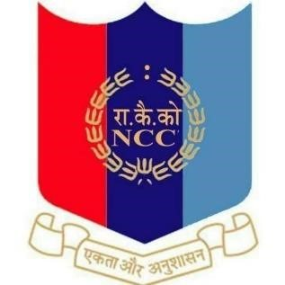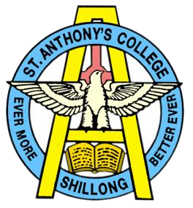

NATIONAL CADET CO
R
PS

ST. ANTHONY’S
COLLEGE

A Don Bosco Institution

Bomfyle Road,
SHILLONG 793001

PRE - REPUBLIC DAY CAMP 2022

As part of NCC Training and selections for RDC 2023 , Pre-Republic Day Camps 1,2,3 and 4 were held in NCC Academy Jorhat. 6 SD’s took part in the camp. The camp dates are as follows:
- Pre RDC 1 ( 10-10-2022 to 17-10-2022)
- Pre RDC 2 (14-11-2022 to 21-11-2022)
- Pre RDC 3 (14-12-2022 to 21-12-2022)
- Pre RDC 4 (22-12-2022 to 29-12-2022)
The cadets went through rigorous screening and selections to make it to final Nominal Roll of NER DTE CONTINGENT. The Cadets had to undergo selections event - wise on volunteer Basis. The various events were Drill , Cultural , BC/YEP, Flag Area. The cadets who cleared all the PRE RD Camps were then sent to Delhi to attend the Republic Day Camp 2023.
The following are the list of SD’s who attended the Pre-Republic Day Camp from St. Anthony’s College:
JUO | PRIYANGKUSH DAS
CDT | YASH THAPA
CDT | AIBORLANG KHARJANA
CDT | BISHAL CHANDA
CDT | PRESENBIRTH . G. MOMIN

