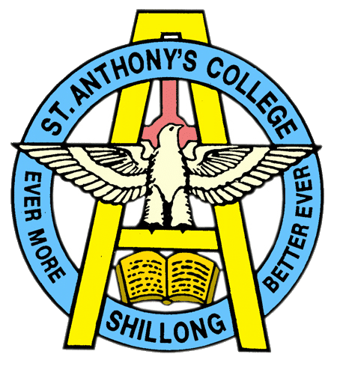
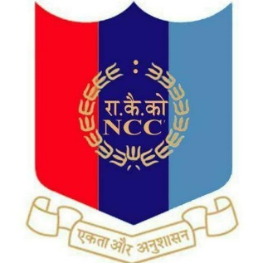
NATIONAL CADET CORPS
ST. ANTHONY’S COLLEGE
A Don Bosco Institution
Bomfyle Road, SHILLONG 793001

Report on Blood donation camp
As part of 75th anniversary of India's Independence Day Celebration,2022. A Blood Donation camp was organised by Indian Red Cross Society (IRCS) and 2nd Meghalaya Battalion NCC , Shillong in collaboration with the Meghalaya State Blood Transfusion Council (MSBTC) and licensed Blood center regional blood centre on the 12th August 2022 at 2nd Meghalaya Battalion NCC , Shillong.
6 (six) St. Anthony's college Cadets had volunteered for blood donation . There were also very prominent cadets of other colleges who were there to donate blood. A certificate of appreciation , donation card , refreshment and a batch was given to each Donor as a token of gratitude .
The following Cadets who Participated in the Blood Donation Camp on the 12th August 2022.
S.No | RANK | REGIMENTAL NUMBER | NAME
1. | SUO | ML20SDA103062 | MARVIN. D . SAWKMIE
2. | SGT | ML20SDA103072 | KALP JALAN
3. | CADET | ML21SDA100012 | ROHIT RAI
4. | CADET | ML21SDA100033 | BIPLOB DEB
5. | CADET | ML21SDA100002 | KHANGJIANLUNG AMOS KAMEI
6. | CADET | ML21SDA100024 | PHYRNAILANG SUTING
