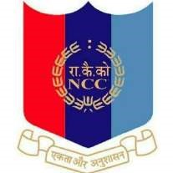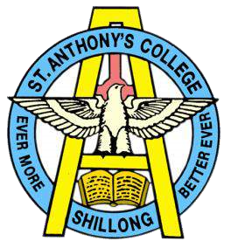

NATIONAL CADET CORPS

ST. ANTHONY’S COLLEGE

A Don Bosco Institution

Bomfyle Road, SHILLONG 793001

Report on Combined Annual Training Camp

As a part of CATC ,NCC Training st. Anthony's college7 Cadets took part in the CATC ( combined Annual Training camp ) held at Assam Regiment Centre Happy valley from 20th July to 29th of July,2022 .This camp is being organised by 2nd Meghalaya Battalion NCC basically for selection of Cadets for Pre-Thal Sainik Camp and Pre-Republic Day Camp.The cadets make their presence felt and won certificate in the various competitions held during the session. JUO. Priyangkush Das from 3rd year grabbed the certificate for .22 rifle shooting in the camp , shooting competition and Cadet Ngamba Singha from 2nd year grabbed the certificate for 2nd best drill in the drill competition. Cadets attended the CATC camp from 20th July to 29th July,2022.

REGIMENTAL NUMBER | RANK | NAME
ML21SDA103052 | JUO | PRIYANGKUSH DAS
ML21SDA103072 | SGT | KALP JALAN
ML21SDA100014 | CDT | BAKHAM MANIK  SYIEMLIEH
ML21SDA1000012 | CDT | ROHIT RAI
ML21SDA100007 | CDT | NGAMBA SINGHA
ML21SDA100006 | CDT | BISHAL CHANDA
ML21SDA100010 | CDT | PUTTU KUMAR SINGH

