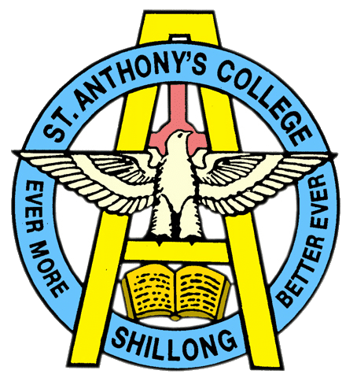
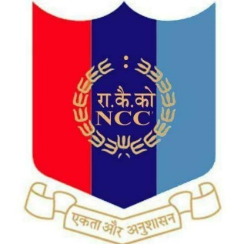
NATIONAL CADET CORPS
ST. ANTHONY’S COLLEGE
A Don Bosco Institution
Bomfyle Road, SHILLONG 793001

Republic Day Camp – Delhi 2022

The prestigious Republic Day Camp was held from 17th December to 29th December which included 15 days of quarantine. So, the actual training started from the 1st of January. After attending a series of rigorous selection of undergoing 3 selection camps, out of 3 cadets from St Anthony’s College 1 was finally selected for attending the Republic Day Camp at Delhi
The detailed cadet for the camp :
- JUO. Rivaaz Subba
The following main events were conducted as competitions in the Republic Day Camp.
1. All India Guard Of Honour
2. Rajpath
3. Prime Minister’s rally
4.Flag area competition
5. Line area competition
6. All India Best Cadet Competition
7. Cultural competition.

JUO Rivaaz Subba was selected for the PM’s rally and was also part of the cultural team of North Eastern Region(NER) Directorate.

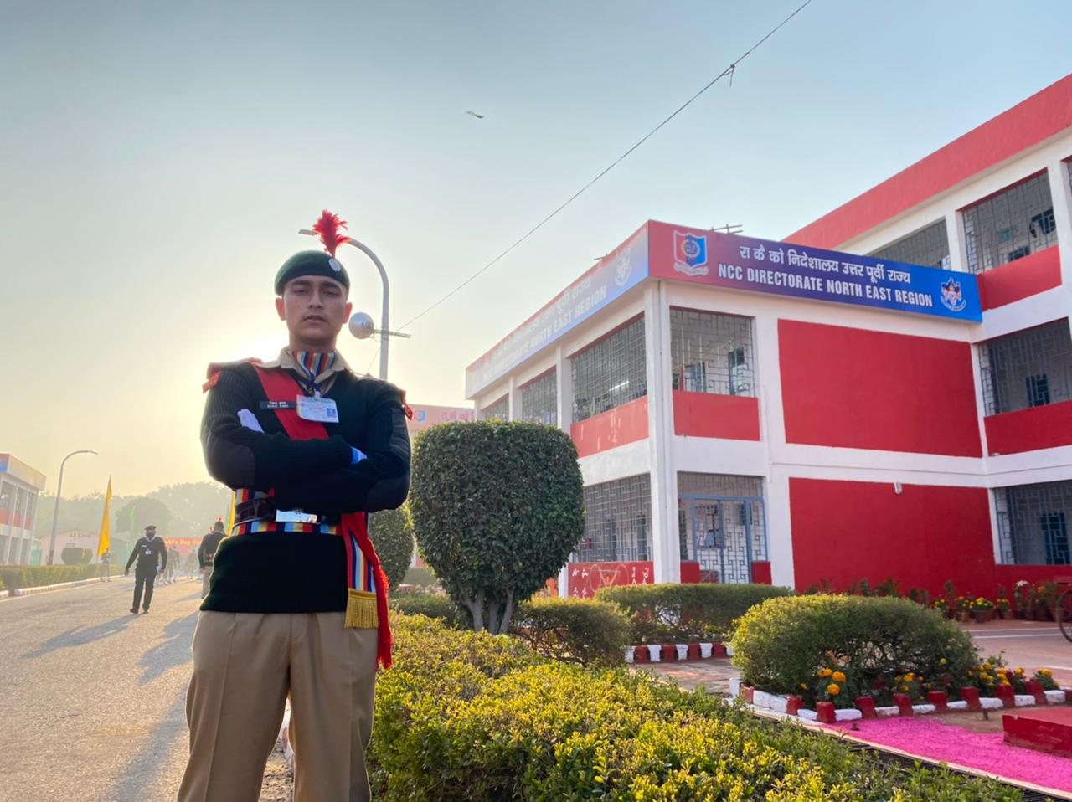

JUO. RIVAAZ SUBBA

