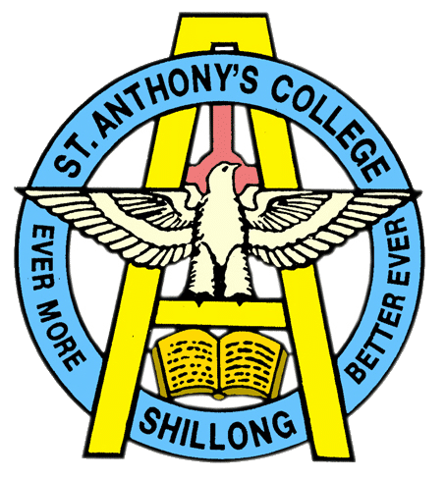
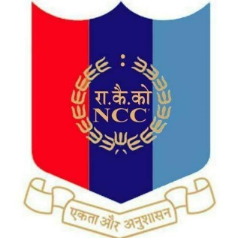
NATIONAL CADET CORPS
ST. ANTHONY’S COLLEGE
A Don Bosco Institution
Bomfyle Road, SHILLONG 793001

Report on International Yoga day
“Yoga for Humanity” 2022

The 8th International Yoga day was observed by National Cadets Corps of St. Anthony’s college. The Yoga Session was held in the Auditorium of the institution under the supervision of Lt.G.S.Swett (ANO) of the college from 9:00 a.m. to 10:00 a.m. The Cadets took active participation in the Yoga session with one Motive that is to inculcate Yoga for Humanity of oneself, for the family and for the society as a whole.
The practice of Yoga is unison towards better health and wellness. Yoga is India’s gift to humanity and it is a holistic approach to health and Well-being, balancing mind, body and soul.
They performed various asanas such as Bhujangasana, Tadasana, Trikonasana, Navasana, Baddha Konasana, Gomuthasana, Garudasana, Salabhasana, Matsyasana, Setu bandha sarvangasana and Virabhadrasana II.
Total 56 cadets participated in the yoga session out of which there were 20 Senior wings and 36 Senior Divisions take active part in the Yoga Session.

Lt.Garland StarSwett
Associate NCC Officer
St.Anthony’s College
