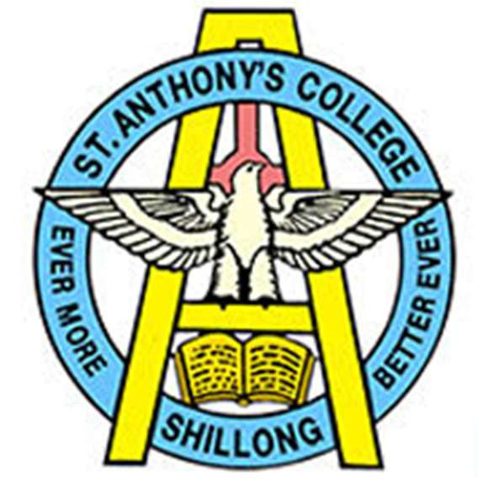ST ANTHONY’S COLLEGE SHILLONG
A Don Bosco Institution
Bomfyle Road Shillong 793001
NAAC Accredited
Phone: 0364 222558, 2223558

Additional Information

Click here

https://anthonys.ac.in/resources/documents/naac/AQAR23-24/Criteria-7/7.1.11

