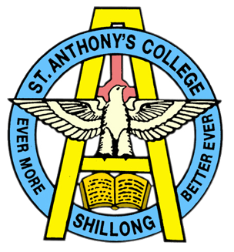
ST ANTHONY’S COLLEGE
(A Don Bosco Institution)
SHILLONG 793 001
Meghalaya - India
NAAC Re-Accredited with ‘A’
College with Potential for Excellence (awarded by UGC)

NAAC Appeal Supporting Documents
Metric 1.1.3

The following supporting documents are hereby provided to substantiate that within metric 1.1.3, the Faculty of the College have been involved in all of the Duties as laid down by NAAC including Faculty involvement in the “Design and Development of Curriculum for Add on/ certificate/ Diploma Courses’.

The Original and Revised Excel files and Supporting Documents for this Metric containing the above updates is linked to below:

- Original Uploaded Excel File 1.1.3
- Original Uploaded Supporting Documents for 1.1.3

- Revised Excel File 1.1.3 (updates are in bold and italics)

Please find the supplementary supporting documents for the Updates in the Revised Excel File 1.1.3 as links below :-

- Certificate Courses offered by Computer Science Department

- Minutes of Meeting related to Certificate Course
- Certification from Principal for above Certificate Course Curriculum design

- Certificate Courses offered by Mass Media Department

- Radio Programmes and Presentation Techniques Syllabus
- Certification from Principal for above Certificate Course Curriculum design
- Sound Designing and Post Production Audio Syllabus
- Certification from Principal for above Certificate Course Curriculum design
- Sound Designing and Post Production Audio (revised) Syllabus
- Certification from Principal for above Certificate Course Curriculum design
- Photo Story Course Syllabus
- Certification from Principal for above Certificate Course Curriculum design
- Crime Scene Photography Course Syllabus
- Certification from Principal for above Certificate Course Curriculum design

- Add On Courses offered by Music Department

- Add On Bridge Course 2017-2018 Syllabus, Schedule and list of Students
- Add On Bridge Course 2018-2019 Syllabus, Schedule and list of Students
- Add On Bridge Course 2020 Syllabus, Schedule and list of Students
- Certification from Principal for Add-On Course Curriculum design 2017_part 1
- Certification from Principal for Add-On Course Curriculum design 2017_ILWM & ALWM
- Certificates given to students for ILWM 2017-2018
- Certificates given to students for ALWM 2017-2018

- Certificate Course offered by Fishery Science Department

- Minutes of Meeting, Short Term Certificate Course Syllabus etc.
- Certification from Principal for above Short-Term Course Curriculum design
- List of Certificate Course attendees
- Certificates given to Certificate Course Attendees

- Add On Course offered by Zoology Department

- Nomination letter to appoint members of Add On Course Syllabus Committee
- Add-On Course (Bee Biology and Bee Keeping) Syllabus
- Certification form Principal for above Add-On Course Curriculum design
- List of students attending the Add On Course

